PS148
89-02-32nd Ave
East Elmhurst, NY 11369
Yolanda Harvey Anna DeLisse
Principal Judith Sommer
2023-2024 Supply List
Kindergarten
Dear Parents/Guardians,

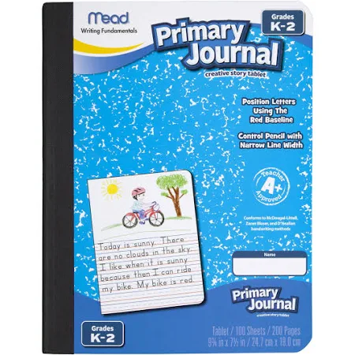
Your child will be entering Kindergarten in September 2023. In order to be sure we start off smoothly, we are requesting your child come to school on the first day with the following items:
- 1 Primary Journal (see picture)
- 2 hard cover black and white notebooks (Mead recommended)
- 2 packs of number 2 pencils (Ticonderoga recommended)
- 2 white erasers (Ex: Paper Mate White Pearl)
- 3 two pocket plastic folders
- Crayola Crayons (24 pack)
- 2 Elmer school liquid glue
- 1 pack of glue sticks
- 2 packages of wipes
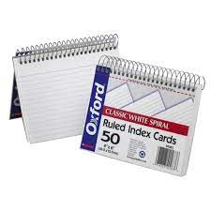
- 1 box of gallon size Ziplock bags (no zipper)
- 1 roll of Bounty paper towels
- 1 box of facial tissues
- 1 pack of 4 black Expo dry-erase markers
- 1 spiral bound index cards (3” X 5”) (see picture)
- 1 bottle of hand soap
- 1 pack of white printer paper
- Backpack (large enough to hold folder, notebook, etc)

*****Please make sure everything is labeled with your child’s name.******
Suggestions for Home: Crayons, scissors, glue and pencils

Being prepared on the first day is a great way to start off a great year. Thank you for helping your child prepare for this school year.

The Kindergarten Teachers

